OBJECTIVES:
- To code a program to transfer data from program memory into RAM locations.
- To code a program to transfer data from RAM locations to other RAM locations.
- To experiment with a look-up table.

MATERIAL:
- Atmel Studio

WEB SITES:
- www.microchip.com for Atmel Studio Software

ACTIVITY 1
Write a program to transfer a string of data from program memory starting at address $200 to RAM locations starting at $140. Using the simulator, single-step through the program and examine the data transfer and registers.
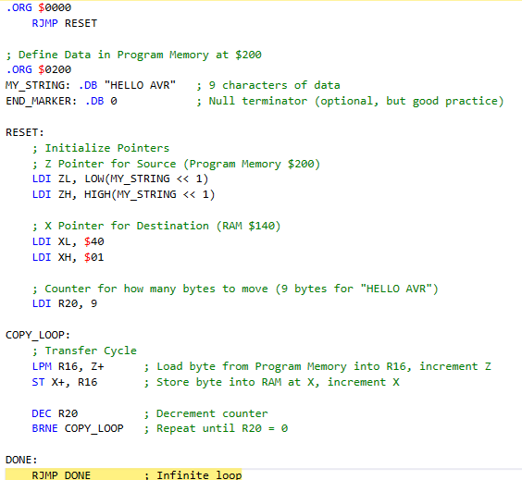

ACTIVITY 2
Add the subroutine to the program in Activity 1. After data has been transferred from program memory into RAM, the subroutine function should copy the data from RAM locations starting at $140 to RAM locations starting at $160. Use single-step through the subroutine and examine the operations.
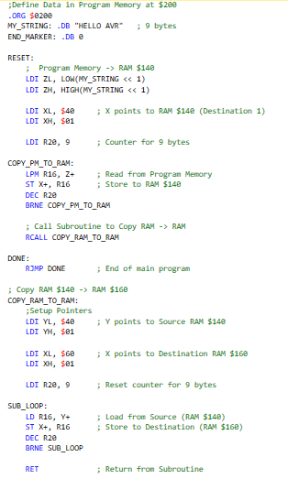

ACTIVITY 3
- Write a program to calculate y where y = x² + 2x + 9. Where x is the number between 0 and 9 and the look-up table for x² is located at the address $200 of program memory. Register R20 keeps the value of x, and at the end of the program R21 should contain the value of y. Use the simulator to change the x value and single-step through the program, examining the changes.
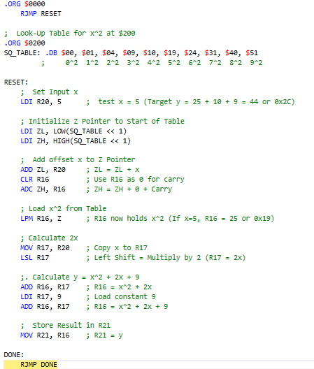

- Explain the difference between the following two instructions:
- LPM R16, Z
(Load Program Memory): Loads a byte from Flash (Program) Memory into a register. It is used for reading constants or look-up tables stored in the code space.

- LD R16, Z
(Load Indirect): Loads a byte from SRAM (Data) Memory into a register. It is used for reading variables or data stored in RAM.

- Circle the invalid instructions.
- LDS R20, 60
- LD R30, Z Invalid cannot load data into R30 using Z as the pointer.
- LD R25, Z+
- LPM R25, Z+4 Invalid. LPM instructions cannot have an immediate offset like
- Explain the difference between the following two instructions:
- LDS R20, $40
(Load Direct from Data Space): Go to SRAM address $40, find the value stored there, and copy it into R20
- LDI R20, $40
(Load Immediate): Simply put the number $40 (hex for 64) directly into R20. It does not access memory.

